. 1. Complete this table, performing all necessary conversions between numeration systems.

Binary | Octal | Decimal | Hexadecimal
 | 162
 |  |  | 6E
 |  | 65
1100111
 |  | 85.23
 | 45.32
101011.111
 |  |  | D9.C

- Complete this table, performing all necessary conversions between Binary to Gray code and Cray code to Binary.

Binary | Gray code
1 0 1 1 0 1 0
1 1 1 0 0 1 1
1 0 1 1 0 0 1
 | 1 1 1 1 0 1 0 0
 | 1 0 1 0 0 1 1
 | 1 0 0 0 1 1 0

3. Given the binary input value 1001, draw a binary-to-Gray code converter logic circuit to provide the Gray code output.

4. Given the Gray code value 1010, draw a Gray code-to-binary converter logic circuit to provide the binary output.

- Determine the two’s complement of the following binary numbers.
  - 0111001
  - 1110101
  - 0011001
  - 1010101

- Convert the following eight-bit sign number into decimal form.

  - 01100111₂
  - 10110011₂
  - 00101010₂
  - 10101010₂

- Add the following eight-bit 2’s complement numbers together, and convert the binary quantity (answer) into decimal.

  - 10101110 b. 01101110
+ 01011100 + 00111101

c. 01011011 d. 01101110
+ 11010001 + 11100101

8. The binary-to-Gray code converter output Gray code value 1 0 1 1 . What is the Binary input value? (Hint: look into the logic circuit)

9. Gray code-to-binary converter output binary value 1 0 0 1 What is the Gray code input value? (Hint: look into the logic circuit)

- [a] Complete the following table for the Half-Adder. Write the Boolean expression for Σ₀ and C₀ then draw a logic gate circuit for this Half-Adder.

A₀ | B₀ | Σ₀ | C₀
0 | 0
0 | 1
1 | 0
1 | 1

[b] Is the following circuit equivalent to a half-adder?

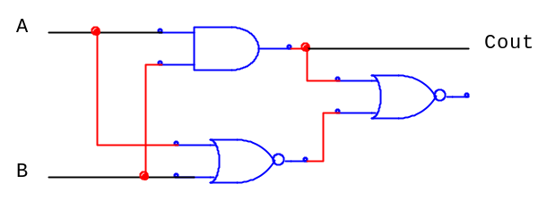

11. [a] Given the truth table for the Full-Adder. Write the Boolean expression and simplify it for Σ₀ and C_{out}

A | B | C_{in} | Σ₀ | C_{out}
0 | 0 | 0 | 0 | 0
0 | 0 | 1 | 1 | 0
0 | 1 | 0 | 1 | 0
0 | 1 | 1 | 0 | 1
1 | 0 | 0 | 1 | 0
1 | 0 | 1 | 0 | 1
1 | 1 | 0 | 0 | 1
1 | 1 | 1 | 1 | 1

[b] What are the full-adder inputs that will produce the following outputs.

a. Σ₀ = 0 and C_{out} = 1
b. Σ₀ = 1 and C_{out} = 1

12. Explain the difference between a ripple adder and a look-ahead adder?

- Explain the purpose of a magnitude comparator?

- What is the difference between the TTL gate and a CMOS device if both the input line left floating?

- The output of the following gate circuit is always low, no matter what states the input switches are in. Assume that CMOS logic gates are being used here.

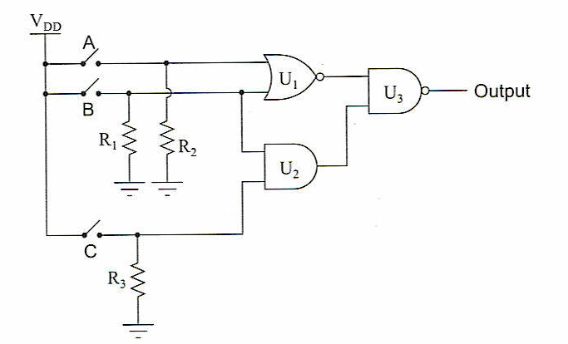

Identify which of these possibilities may account for the output always being low, or anything you can add to the following list.
- Output of U₁ stuck in a high state.
- Output of U₂ stuck in a high state.
- R₁ failed open.
- R₂ failed shorted
- R₃ failed shorted
- Switch A failed open
- Switch B failed shorted
- Switch C failed shorted.

